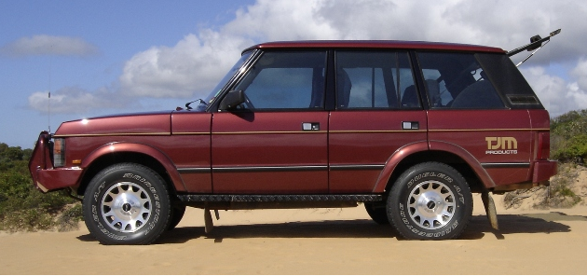

1990 Range Rover

2nd owner for past 13years, 1st owner TJM Brisbane
3.9 V8 4 speed Auto with lockup clutch, viscous coupling
Air conditioned, power steering, electric windows

275000 km always serviced on time
Tinted windows
Mags with 694 Bridgestone tyres
ARB diff lock
ARB air compressor with rear outlet and gauge in dash

TJM high grade aluminium Bull Bar
Headlight upgrade with protectors, Cibie Spot Lights

Dash mounted GME UHF Radio
Upgraded stereo with 6 stacker CD

TJM colour coded flares
3 fuel tanks giving a total of 170 litres

Dual Batteries with TJM controller
TJM rear step
TJM colour coded Roof Rack
Extra sound deadening, Rubber Mats

Power outlets for Fridge and Lights
Tow Bar and wiring
Electric Brake controller
Unichip power upgrade
High flow K&N air filter
Heat coated extractors
TJM suspension and adjustable gas shocks
TJM Front and rear Sway Bars
TJM running Boards

